Multiple-choice section – choose the correct answer

Question 1 [1.1]

Calculate -5 − (+ 4) + 3.

A 4 B -6 C -1 D -12

Question 2 [1.2]

Calculate 6 × -2 × -3.

A 36 B -36 C 12 D -24

Question 3 [1.3]

Calculate 36 ÷ -4.

A 34 B 9 C -12 D -9

Question 4 [1.5]

Calculate (-3)2 + (-2)3.

A 12 B 17 C 1 D -12

Question 5 [2.1]

Write 5.817 as a fraction in simplest form.

A 5 $\frac{817}{10}$ B 5 $\frac{8}{17}$ C 5 $\frac{817}{100}$ D 5 $\frac{817}{1000}$

Question 6 [2.2]

The value of $\sqrt{20}$ is closest to:

A 4.5 B 4.35 C 4.4 D 4.65

Question 7 [2.5]

The decimal 1.05 as a percentage is:

A 1.05% B 105% C 150% D 10.5%

Question 8 [3.2]

If *a* = 3 and *b* = 7, then 3*a* – 4*b* is equal to:

A -5 B -1 C 35 D -19

Question 9 [3.4]

4*x*2 + 3*xy* – 7*yx* + 7*x*2 + *x* simplified is:

A 11*x*2 + 3*xy* – 7*yx* + *x* B 12*x*3 – 4*xy*

C 11*x*2 – 4*xy + x* D 8*x*5*y*

Question 10 [4.2]

Write the ratio 5 cm : 4 mm in simplest form.

A 5 : 4 B 50 : 4 C 25 : 2 D 5 : 40

Question 11 [5.3]

A circle of diameter 10 cm has a perimeter, correct to 2 decimal places, of:

A 314.00 cm B 31.42 cm C 31.40 cm D 31.41 cm

Question 12 [5.7]

What is the capacity of 1 m3?

A 1 kL B 100 L C 100 000 mL D 10 kL

Multiple-choice results: ___ /12

Short answer section

Question 13 12 marks

Choose the correct word from the following list to fill each of the gaps in the following sentences.

*base percentage coefficient power capacity variable   
decimal index ratio circumference exponent pronumeral*

(a) The fraction $\frac{2}{5}$ written as a ____________________ is 40% and as a ______________ is 0.40.

(b) In the expression 42, the 4 is known as the ________ and the 2 is called the _______ or ________.

(c) A __________ is a comparison of two amounts of the same type.

(d) The distance around the outside of a circle is called the _______________________________.

**(e)** In the term 4*x*, the number 4 is called the _________________ and the *x* is identified as the _____________________ or ___________________.

**(f)** _______________ is a term used for the volume of space inside a container.

Question 14 4 marks [3.1, 5.1, 5.4, 5.7]

(a) Explain in words the difference between an expression and an equation and   
give an example of each.

(b) Draw shapes and solids to demonstrate the difference between perimeter, area and volume.

Question 15 2 marks [1.1]

Arrange the following numbers in ascending order (smallest to largest).

-4, 7, 0, -2, 4, 1, -1

Question 16 5 marks [1.4]

Evaluate the following.

(a) 2 – 3 × 4 + 8

(b) 12 + 30 ÷ 5 × (2 × 5) – 10 + 3 × 2

Question 17 4 marks [1.6]

Evaluate the following.

(a)  (b) (-3)2 × (-2)3

Question 18 4 marks [2.3]

Calculate the following, writing your answer in simplest form.

(a) $-\frac{2}{5}+ \frac{1}{3}$ (b) $\frac{5}{12} ÷ -\frac{2}{3}$

Question 19 5 marks [2.3]

Calculate the following, writing your answer in simplest form.

(a) 6.99 – 3.12 (b)  ÷ -1.5

Question 20 2 marks [2.5]

Find the percentage that is equivalent to each of the following.

(a) 0.85 (b) 2 $2\frac{3}{20}$

Question 21 3 marks [2.6]

Kate achieved the following scores on three pieces of assessment:

English:  Maths:  Science: 80% $\frac{17}{20}$

In which subject did she acheive the best result?

Question 22 2 marks [2.8]

Find the following.

(a) 10% of $550 (b) 120% of 40 minutes

Question 23 3 marks [2.9]

Phil buys $5000 worth of shares. At the end of the first week after buying them, the shares have increased in value by 4%.

(a) What is the total value of the shares after the first week?

(b) By the end of the second week, the share price had decreased by 4% of its value at the end of the first week. What is the total value of the shares at the end of the second week?

Question 24 3 marks [3.2]

If *x* = 4 and *y* = 6, calculate the value of the following.

(a) 2*x* + *y* (b) $\frac{4(3x+y)}{y^{2}}$

Question 25 2 marks [3.4, 3.5]

Simplify the following.

(a) 2*a* + 6*b* + 5*a* – 4*b* (b) 4*a* × 8*a* × -*b*

Question 26 3 marks [3.6]

Expand and simplify the following.

(a) 2(3*x* + 5) (b) 3(2 + *x*) – 4(*x* – 2)

Question 27 2 marks [3.7]

Factorise the following expressions.

(a) 15*a* – 25 (b) 8*mn*2 + 12*m*2*n*

Question 28 2 marks [4.2]

Simplify the following ratios, taking into account the associated units.

(a) 10 : 25 (b) 15 m : 450 cm

Question 29 2 marks [4.4]

Determine the unknown values in the following ratios.

(a)  = $\frac{3 }{8}=\frac{a}{48}$ (b)  = $\frac{12}{b}=\frac{8}{12}$

Question 30 2 marks [4.6]

A sum of $240 is to be divided between three friends in the ratio 4 : 5 : 6. Calculate the amount of the largest share.

Question 31 2 marks [4.7]

Frank needs to buy some sliced pineapple. The pineapple can be bought in two sizes. A 500 g can of costs $2.40 and a 750 g can costs $3.40. Which can is the best value for money? Clearly identify the reason behind your decision.

Question 32 2 marks [5.1]

Find the perimeter of the following shape.

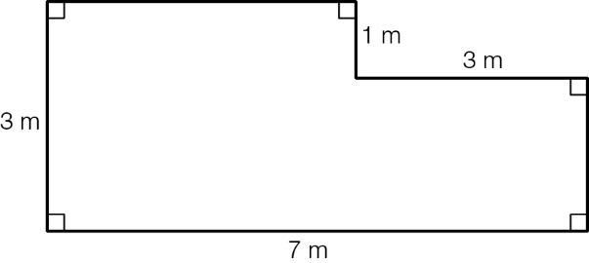

Question 33 2 marks [5.3]

Calculate the perimeter of the following shape. Round your answer to 2 decimal places where necessary.

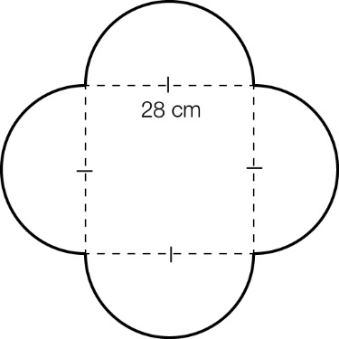

Question 34 4 marks [5.4]

Calculate the area of each of the following shapes.

(a)

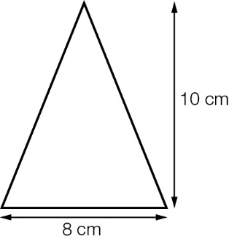

(b)

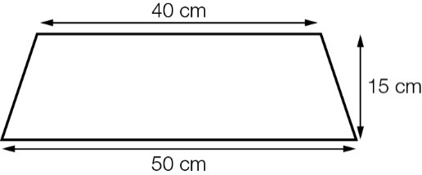

Question 35 6 marks [5.6]

Find the shaded area of the following composite shapes. Round your answers to 2 decimal places where necessary.

(a) (b)

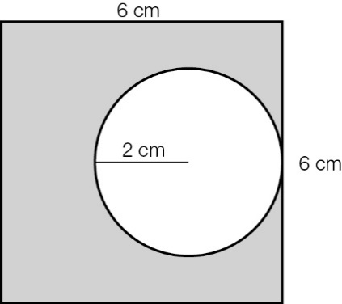 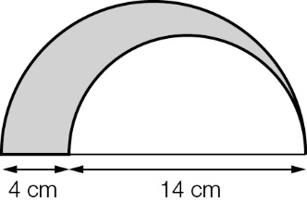

Question 36 2 marks [5.7]

Find the capacity of the following solid, in millilitres. Round your answers correct to 2 decimal places where necessary.

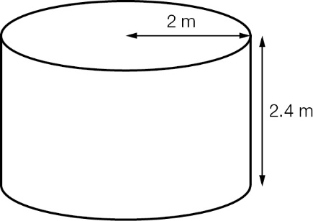

Short answer results: ___ / 80

Extended answer section

Question 37 3 marks [1.4]

On a test, each correct answer scores 5 points, each incorrect answer scores -2 points, and each question left unanswered scores 0 points.

Assume you answer all 20 questions on the test. What is the greatest number of questions that you can answer incorrectly and still get a positive score? Show your working and reasoning to gain full marks.

Question 38 3 marks [2.10]

In a jewellery shop, the marked price on a diamond ring is $2550. The shop advertises that all stock is discounted by 20%. On Saturday, the shop advertises a further discount of 20%. Find the overall percentage discount offered on the diamond ring.

Question 39 6 marks [5.7]

A box without a lid can be made from a square sheet of paper 12 cm by 12 cm by cutting a square from each corner and folding up the flaps.

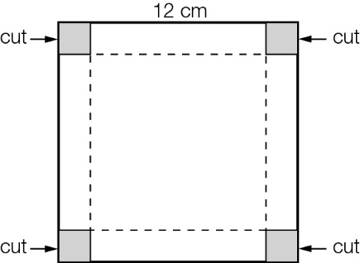

(a) Investigate the volumes of box that are possible for different sizes of cut-out squares (write down five different examples).

(b) What is the maximum possible volume and what size cut produces it?

Extended answer results: ___ / 12

TOTAL test results: ___ / 104